**Self-Driving Car Studio**

Customizing the QCar User Manual

© 2023 Quanser Inc., All rights reserved

For more information on the solutions Quanser Inc. offers,   
please visit the web site at: <http://www.quanser.com>

|  |  |
| --- | --- |
| Quanser Inc.  119 Spy Court  Markham, Ontario  L3R 5H6, Canada | info@quanser.com  Phone : 19059403575  Fax : 19059403576  printed in Markham, Ontario. |

This document and the software described in it are provided subject to a license agreement. Neither the software nor this document may be used or copied except as specified under the terms of that license agreement. Quanser Inc. grants the following rights: a) The right to reproduce the work, to incorporate the work into one or more collections, and to reproduce the work as incorporated in the collections, b) to create and reproduce adaptations provided reasonable steps are taken to clearly identify the changes that were made to the original work, c) to distribute and publicly perform the work including as incorporated in collections, and d) to distribute and publicly perform adaptations. The above rights may be exercised in all media and formats whether now known or hereafter devised. These rights are granted subject to and limited by the following restrictions: a) You may not exercise any of the rights granted to You in above in any manner that is primarily intended for or directed toward commercial advantage or private monetary compensation, and b) You must keep intact all copyright notices for the Work and provide the name Quanser Inc. for attribution. These restrictions may not be waved without express prior written permission of Quanser Inc.

**FCC Notice** This device complies with Part 15 of the FCC rules. Operation is subject to the following two conditions: (1) this device may not cause harmful interference, and (2) this device must accept any interference received, including interference that may cause undesired operation.

**Industry Canada Notice** This Class A digital apparatus complies with Canadian ICES-003. Cet appareil numérique de la classe A est conforme à la norme NMB-003 du Canada.

**Waste Electrical and Electronic Equipment (WEEE)**

This symbol indicates that waste products must be disposed of separately from municipal household waste, according to Directive 2002/96/EC of the European Parliament and the Council on waste electrical and electronic equipment (WEEE). All products at the end of their life cycle must be sent to a WEEE collection and recycling center. Proper WEEE disposal reduces the environmental impact and the risk to human health due to potentially hazardous substances used in such equipment. Your cooperation in proper WEEE disposal will contribute to the effective usage of natural resources.

|  |  |
| --- | --- |
|  | This product meets the essential requirements of applicable European Directives as follows:   * 2006/95/EC; Low-Voltage Directive (safety) * 2004/108/EC; Electromagnetic Compatibility Directive (EMC)   **Warning**: This is a Class A product. In a domestic environment this product may cause radio interference, in which case the user may be required to take adequate measures. |
| caution.png **Caution** | **This equipment is designed to be used for educational and research purposes and is not intended for use by the public.** The user is responsible to ensure that the equipment will be used by technically qualified personnel only. While the end-effector board provides connections for external user devices, users are responsible for certifying any modifications or additions they make to the default configuration. |

# Table of Contents

A. Overview 3

B. Mechanical 3

Chassis 3

Bumpers 3

Suspension 6

Mechanical Breadboard 7

C. Electrical 8

D. Software 8

Linux Packages 8

QUARC 10

Python 11

# A. Overview

The QCar has been designed as a research tool, and with that in mind, we have strived to make it as flexible and customizable as possible. The following sections try to give you guidance on modifying your QCar. If you have questions, please contact tech@quanser.com, and we will try to give you any additional information or recommendations you require.

# B. Mechanical

## Chassis

The QCar chassis is built on a Traxxas ([www.traxxas.com](http://www.traxxas.com)) platform. Their products are highly customizable, and you can find a variety of parts to modify the steering, suspension, tires, and other elements.

## Bumpers

The foam bumpers were custom designed and extensively tested to minimize damage to the mechanical and electrical systems in the event of a collision running at the maximum rated speed (3m/s). If you make significant changes to the mass of the vehicle, it may be necessary to enhance the bumpers to provide the same level of protection.

The rear bumper can be removed by these two screws:

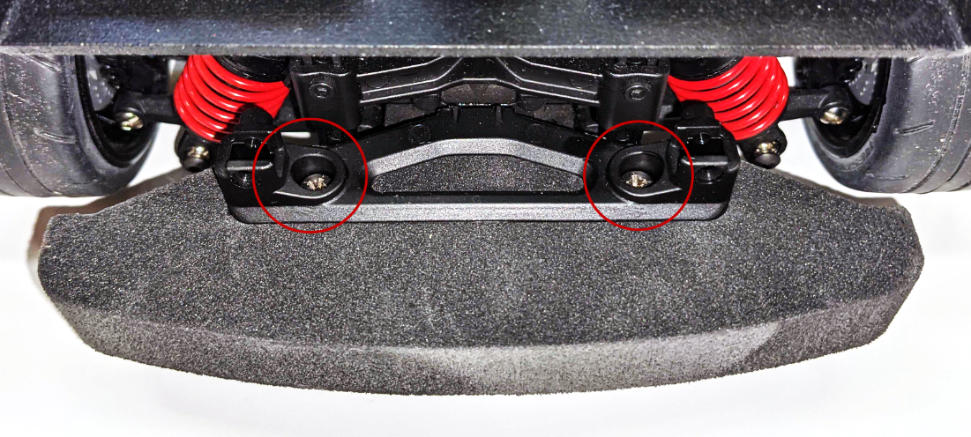

To access the front bumper requires removing the metal frame from the chassis. First shutdown the QCar and disconnect and remove the battery.

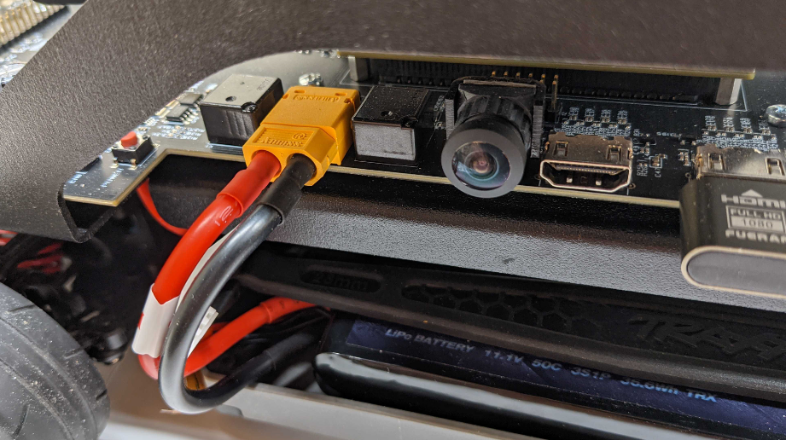

Next disconnect the encoder and servo (be sure to note the servo connector polarity). It may be necessary to cut the plastic tie holding the wires:

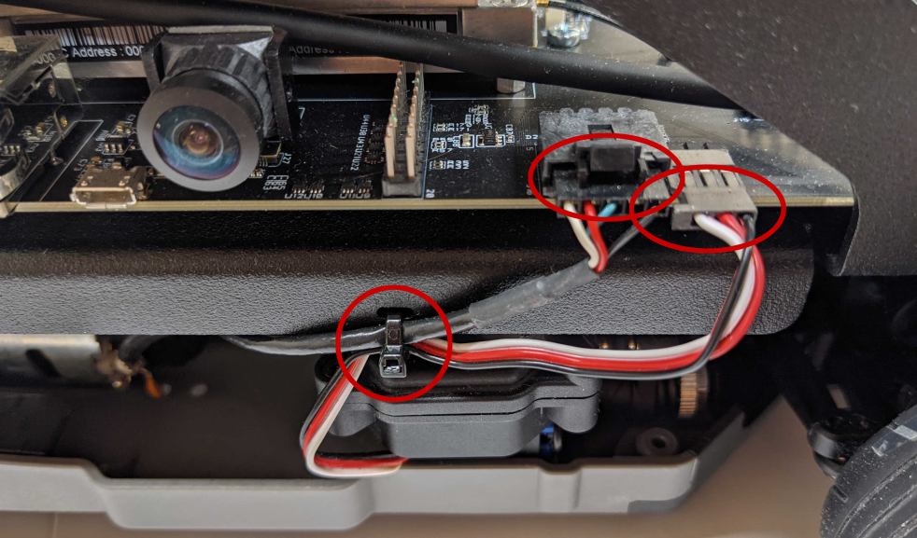

Remove the 4 indicated screws to separate the metal frame from the lower chassis and carefully move it to the side (the motor wires will still be connected).

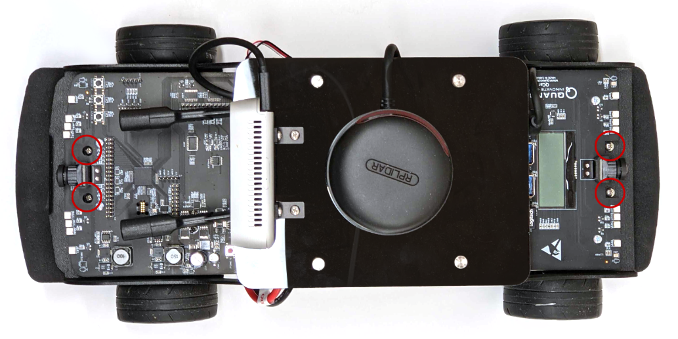

Use an Allen key to remove the three screws on the front post and this will release the front bumper:

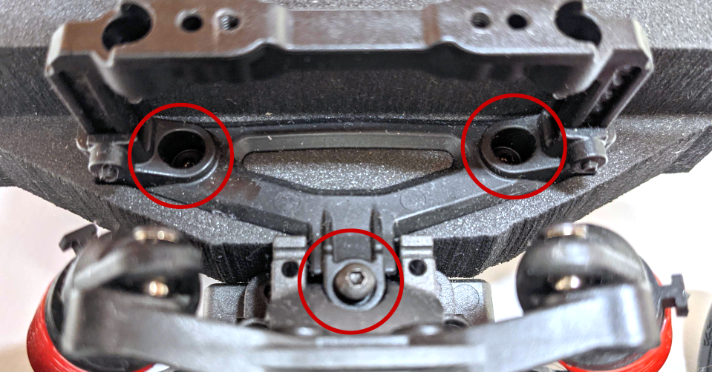

Reverse all the steps to reassemble the QCar when you are complete. Take care to only tighten the frame screws finger-tight to avoid stripping the hole.

## Suspension

The QCar suspension has been tuned for the default payload. Significant changes to the mass may require that you retune the suspension. If there is a large additional mass added, you should try changing the **spring pre-load spacer** (available from Traxxas or you can 3D print one):

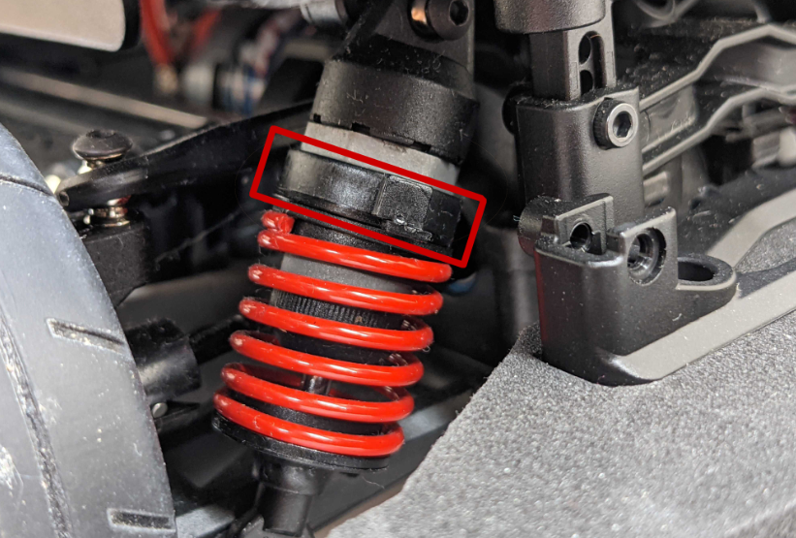

If the spacer does not provide enough additional force, the springs can be replaced. If that still does not provide enough force, the entire shock mechanism can be replaced with alternatives from Traxxas.

## Mechanical Breadboard

The top mechanical plate is designed to be easily drilled or cut to accommodate your own custom attachments or sensors. This can be made of virtually any material, but we recommend a plastic such as acrylic or polycarbonate to avoid the risk of any metal shards landing on the PCB or other electronics and causing damage.

A DXF outline file (QCar Mechanical Breadboard.dxf) is included in the **Supporting Documentation** folder for direct use with CNC or laser cutters, or it can be imported into a CAD program to modify.

Also, to avoid metal shards, we do not recommend drilling or cutting the metal frame. The use of an adhesive or clamping mechanism is preferred.

# C. Electrical

The QCar has extensive options for adding custom sensors and actuators for your research. Please see the pinouts in the User Manual - System Hardware. While some of the signals are 5V tolerant, most of the IO is 3.3V or 1.8V. Although 5V, 3.3V, and 1.8V is provided to power devices, it is the user’s responsibility to use the appropriate level translator or divider circuits to adjust the input voltage to the appropriate level. Voltages in excess of the indicated signal voltages **will cause permanent damage** to the PCB. Likewise, the signal outputs are not strong enough to power most devices directly. If you wish to power motors, LED’s or other devices using an IO pin, an amplifier or power switch must be used in between. Please also review the **Electrical Considerations** in the User Manual - System Hardware for limits on current consumption.

To access the GPIO or communication interfaces:

|  |  |
| --- | --- |
| **Programming Environment** | **APIs Available** |
| MATLAB/SIMULINK | Simulink HIL/Stream blocks |
| Python | Python HIL/Stream Classes |
| C++ | C++ HIL/Stream .h files |

Table 1. QCar IO access depending on software environment.

# D. Software

## Linux Packages

The QCar comes pre-installed with dozens of software packages and API’s, many of which have been specifically optimized for the TX2 processor with the JetPack SDK (for a detailed list of JetPack features see <https://developer.nvidia.com/embedded/jetpack> for more information). These are in addition to the standard Ubuntu 18.04 LTS packages. Key additions include:

|  |  |
| --- | --- |
| * CUDA (CUDA Toolkit) * CUDA-X AI (cuDNN and TensorRT) * OpenCV * VisionWorks * VPI * NVIDIA Container Runtime (for Docker) * Multimedia API’s including gstreamer * Deep Stream * librealsense2 (including kernel patches to support the Intel RealSense family) | * Prerequisites for MATLAB GPU   Coder (libsdl1.2-dev and v4l-utils)   * libfreenect * ROS2 (dashing) * ROS1 (melodic) * ros1_bridge * vision_opencv * hector_slam |

If you need a more recent version of a package, the first thing to check is the **Software Updater**. Right click on the Software Updater icon, and select Software Updater to view the list of updates available.

If you are following examples that require a specific version of JetPack that does not match components that are installed, please contact tech@quanser.com. JetPack is designed for the TX2 development kit. The operating system and some kernel drivers have been customized and optimized specifically for the QCar hardware. **Any software operation requiring the use of the recovery button should never be used except when directed by Quanser.** Directly reflashing the QCar with a new JetPack SDK will result in the QCar being non-operational.

To view the complete list of packages installed, open a terminal window and type the following command:

sudo apt list –installed | more

This will indicate which version of each package is installed as well as the version it can be upgraded to if available.

## QUARC

The QUARC Target on the QCar manages all the remote execution of compiled code from Simulink or other advanced toolchains from a remote PC. It also contains the most up-to-date drivers for QCar-specific hardware and API’s for C code.. The QCar ships with the most recent released version of QUARC at the time of manufacturing. In most cases, you can run a newer version of QUARC on your development PC than the target (the QCar). If an update is required, this will be advised in the QUARC and QCar Content change logs.

1. Contact tech@quanser.com to obtain a copy of the target installer and target license file. If the file(s) are in a zip container, please extract them first.
2. Use WinSCP to copy the linux_nvidia folder to either /home/quser/Downloads or /home/nvidia/Downloads (which ever folder exists on your QCar)
3. Copy the license file to /home/quser or /home/nvidia and rename it to license.qlic if necessary
4. Connect a keyboard, mouse, and monitor to the QCar or use one of the remote connection methods described in the **Connectivity** user manual.
5. Open a terminal window on the QCar and run the following commands:

sudo /opt/quanser/quarc/bin/uninstall_runtime

1. Confirm y you want to uninstall QUARC.

cd ~/Downloads/linux_nvidia

sudo chmod u+x setup uninstall_quarc_runtime

sudo ./setup

1. Read through the license agreement using Enter to go through each page.
2. Type yes to agree to the license
3. After the installation is complete, type y to configure the license now
4. Select option 3 to configure both the license manager and QUARC
5. Press Enter for the license folder (/home/quser or /home/nvidia)
6. Press Enter for the license file name (license.qlic)

QUARC should now be upgraded on your QCar. It is advised that you upgrade the Quanser Python API’s

## Python

All the Python packages used in the examples come preinstalled on the QCar. These include:

* Python3 packages for TensorFlow (optimized for the QCar),
* cffi
* numpy
* cython
* opencv
* matplotlib
* pygame
* sklearn
* pyquaternion

To view the complete list of Python packages, open a terminal window and type the following command:

python3 -m pip3 list

This will also indicate the version of each package installed. The various quanser-xxx packages should generally be upgraded when updating QUARC on the QCar at the same time to ensure all the API’s remain in sync. To do this, first complete the QUARC update procedure as detailed in the previous section. Next, open a terminal window and run the following command:

cd /opt/quanser/python

ls

Typing ls will indicate the date needed for the next command:

sudo python3 -m pip3 install -–upgrade –-find-links . quanser_api-<date>-py2.py3-none-any.whl

where <date> is the date for the API being installed. For example:

sudo python3 -m pip3 install –-upgrade –-find-links . quanser_api-2021.4.1-py2.py3-none-any.whl

The terminal window should indicate that all existing packages were successfully uninstalled, then the new packages were installed.

© Quanser Inc. All rights reserved.

Solutions for teaching and research. Made in Canada.